Civil servants bungle numbers on Heathrow’s third runway
Department for Transport officials misused an ‘appraisal tool’ when assessing the benefits of expansion
06 September 2026 8:00am BST
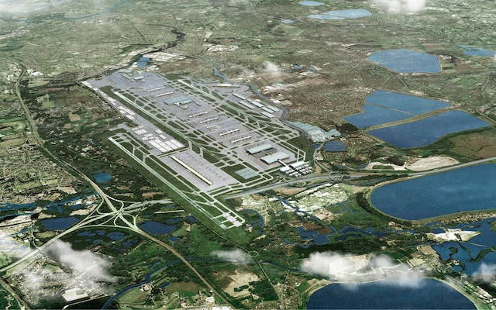
Artist’s impression of the third runway at Heathrow Credit: Heathrow Airport/PA

The economic benefits of a third runway at Heathrow were underestimated by several billion pounds as a result of bungled calculations by civil servants.
Officials at the Department for Transport (DfT) misused an “appraisal tool” when assessing the benefits that would come from the new runway freeing up capacity at other airports.
The error was disclosed by Ian Mulheim, the department’s chief analyst, who apologised for the mistake, which he said would lead to a “material change” in the assessment of the runway’s benefits.
Appearing in front of the transport select committee, he said: “We haven’t finalised exactly the scale of this. We hope to do so in the coming days and write to you about what the scale of it is.”
Pressed on the size of the miscalculation by Ruth Cadbury, the Labour MP for Brentford and Isleworth, who chairs the committee, he said: “It is billions. It’s likely to be billions.” He added: “Apologies for missing that.”
Mr Mulheim said the discrepancy related to estimates of benefits to passengers at Gatwick airport that would accrue as a result of Heathrow’s £49bn expansion.
He said: “With some of the changes we have made, terminal capacity constraints at some other airports become more important, and some of the benefits from expansion at Heathrow actually occur at those airports because it relieves pressure on them.
“What we’ve found is that there is a significant chunk of benefits at Gatwick airport. Those constraints are relieved by the expansion of Heathrow and that was not included or not captured in the initial analysis.”

In a letter to the committee first disclosing the error, sent on the eve of his appearance, he said the approach adopted by civil servants was the same as in the last calculation of the runway’s benefits eight years ago, when it “produced correct results”.
However, he said changes in the balance of runway and terminal capacity constraints at Gatwick while the appraisal of Heathrow was under way had not been anticipated.
“As a result, the analytical approach requires wider revisions to capture all of the passenger benefits accruing at Gatwick Airport,” he said.
While the error meant the benefits of the runway to passengers and the wider economy were underestimated, Mr Mulheim said he was “fairly certain at this stage that it doesn’t change any of the qualitative conclusions of the economic case”.
Sources at Gatwick and Heathrow said it was not clear from Mr Mulheim’s letter exactly what calculations were being referred to and that they had sought clarity from the DfT but had so far received no further explanation. Ms Cadbury said she expected to receive more detail beyond what was contained in the letter.
The DfT’s analysis of the case for the runway, published in June, said it would boost GDP by no more than 0.05pc – or a tenth of the 0.5pc previously stated.
It said the net value of the plan, even when privately financed, would be between minus £23.4bn and minus £62.5bn, with benefits to passengers and the economy of £29bn to £42.4bn outweighed by social and environmental costs of £58bn and £82bn.
Profits at airlines and other airports – including Gatwick – were expected to fall by about £25bn, according to the appraisal.
The DfT said the omissions, while a “technical correction” and not directly concerning Heathrow, were important because analysis of the runway plans must consider the whole aviation network, including how the scheme will shift demand between airports.
A spokesman said responses to the expansion blueprint proposed by the Government as a prelude to seeking planning permission are under consideration and that ministers “will be setting out next steps in due course”.

